OPERE PRESENTI
WORKS PRESENT

AL / AT MOMA

THE MUSEUM OF MODERN ART (NEW YORK)

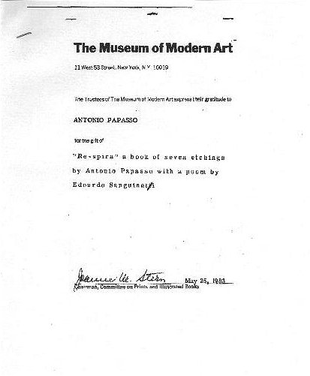

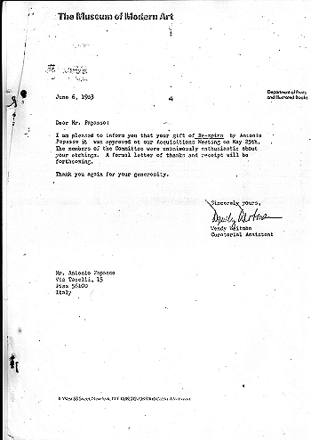

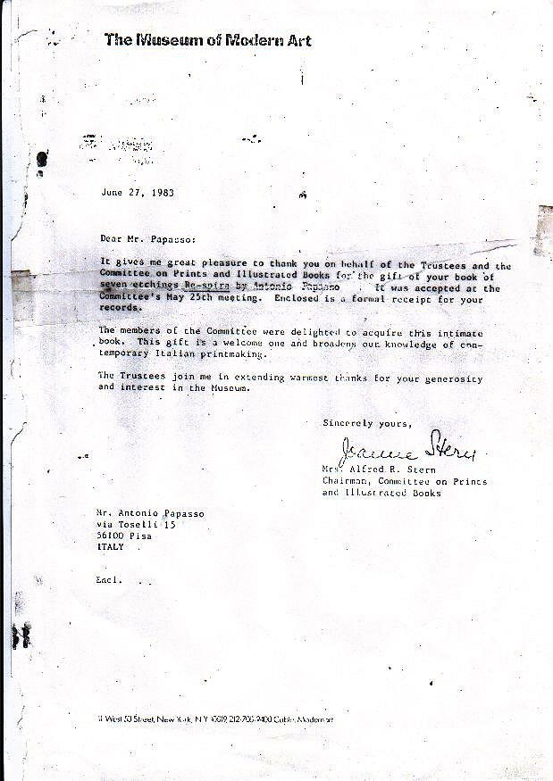

Particolare della lettera sopra pubblicata/A parte of the letter published above

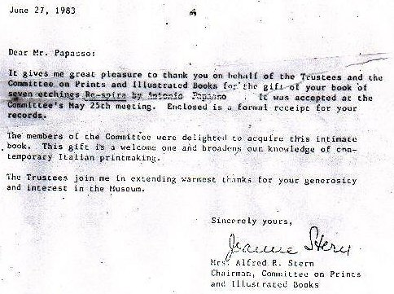

Re-spira | Raccolta di 7 opere di Antonio Papasso con lettura poetica delle opere (triplice acrostico) di Edoardo Sanguineti | 1982
“Il colore è mio” | Catalogo per la Mostra di Antonio Papasso alla Sala Consiliare del Comune di Bracciano (Roma). Nel catalogo, l’opera “Pensierini per Papasso” di Edoardo Sanguineti. | 1998-1999

Checklist of Works by Antonio Papasso
in The Museum of Modern Art, Department of Prints and Illustrated Books
Plate (folio 4) from RE-SPIRA, 1982
Soft ground etching and aquatint, printed in color
plate 2 3/8 x 1 3/4" (6.1 x 4.5 cm)
576.1983.1
RE-SPIRA, 1982
7 etchings (most with drypoint, aquatint, and/or collage) and 1 soft ground etching and aquatint: 2 printed in black, 5 printed in color, and 1 printed without ink (front cover)
sheet 4 5/8 x 3 1/2" (11.8 x 8.9 cm)
page 4 13/16 x 3 9/16" (12 x 9.1 cm)
Prints: various dimensions.
Gift of the artist
576.1983.1-8
Plate (folio 5) from RE-SPIRA, 1982
Etching, printed in color
plate 2 5/8 x 1 7/16" (6.7 x 3.7 cm)
576.1983.2
Plate (folio 6) from RE-SPIRA, 1982
Etching and aquatint, printed in color
plate 2 13/16 x 2 1/8" (7.2 x 5.4 cm)
576.1983.3
Plate (folio 7) from RE-SPIRA, 1982
Etching and drypoint, printed in black
irreg. composition 1 15/16 x 1 5/8" (4.9 x 4.2 cm)
576.1983.4
Plate (folio 8) from RE-SPIRA, 1982
Etching, printed in color, with collage
irreg. composition 2 9/16 x 2 1/4" (6.5 x 5.8 cm)
576.1983.5
Plate (folio 9) from RE-SPIRA, 1982
Etching, aquatint, and drypoint, printed in color
irreg. plate 2 1/2 x 1 1/4" (6.4 x 3.2 cm)
576.1983.6
Plate (folio 10) from RE-SPIRA, 1982
Etching, printed in black, with collage
composition 2 3/4 x 1 3/4" (7 x 4.4 cm)
576.1983.7
Checklist of Works by Antonio Papasso (continued)
Front cover (variant of plate from folio 7) from RE-SPIRA, 1982
Etching, printed without ink
irreg. composition 1 15/16 x 1 5/8" (5 x 4.2 cm)
576.1983.8
Inizio modulo

Search Request: Author/Artist Browse = Papasso
Search Results: Displaying 1 of 1 entries

Papasso : "il '[color]' è mio" : papiers froissés e raccolte incisorie =...

Main Author: | Papasso, Antonio, 1932-
Other Author(s): | Sanguineti, Edoardo.  Ferri, Maurizio.  Comune di Bracciano (Italy). Sala Consiliare.
Title: | Papasso : "il '[color]' è mio" : papiers froissés e raccolte incisorie = papiers froissés and the print collection / Edoardo Sanguineti ; a cura di Maurizio Ferri. [potoes di Marco Manenti].
Portion of Title: | Colore è mio
Publisher: | Bracciano : [Associazione Onlus "Trinità dei Laghi"], 1999.
Subject(s): | Papasso, Antonio, 1932- Exhibitions.
Description: | 1 v. (unpaged) : col. ill.
Notes: | Catalog of an exhibition held December 5, 1998-January 5, 1999 at Sala Consiliare, Comune di Bracciano, Italy.  On t.p. '[colors]' appears as marks of colors.  Includes bibliographical references.  Italian and English.
Location: | Library Stacks
Call Number: | AEC PAPASSO 1999 0630
Number of Items: | 1
Status: | Not Charged

